LOCATION RECCE
SCOUTING OUT
I have decided to scout out the media studio in Bracknell and Wokingham College. It is a large space where there is a lighting set up and a green screen so that we can film and then change the background in editing. It can fit at least 30 people without any problems so is easy enough to bring in filming equipment and other necessary crew and talent required to film the video.

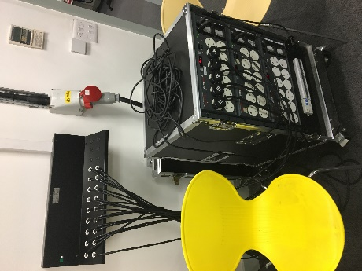
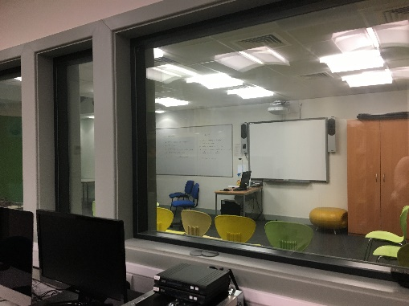
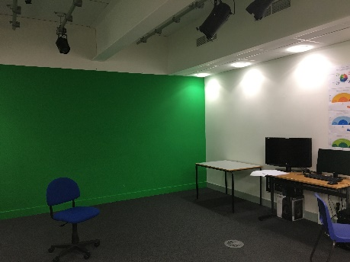
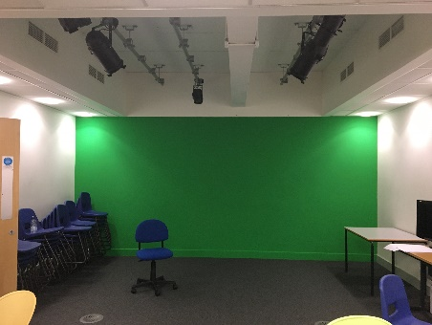
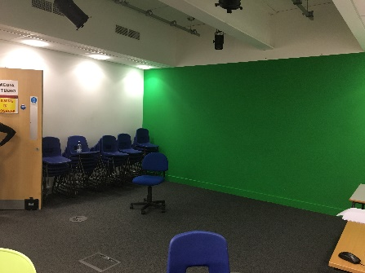
PHOTOGRAPHIC EVIDENCE
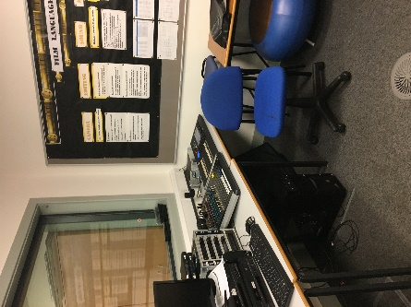

LIGHTING
There is a lighting rig and set up in the room that is easily accessible as there is no natural lighting in the room. It has a lighting desk to adjust the brightness and can be turned into a completely dark area if necessary.

SAFETY
As it is very powerful lighting it means that it can become very hot so it could be dangerous for people to move or touch them after they have been on. Also, wires would be all over the set so the crew and cast must be careful when walking around set. Finally, whenever the lights are off it will be quite dark so movement should be limited to only necessary movements until the lights turn on.

RESTRICTIONS & LEGAL MATTERS
The room is owned by Bracknell and Wokingham College and as a student there I have free use over the media rooms and equipment with permission from the teachers. The only restriction I may encounter would be running into other groups and students needing to use the same space so the time limit might be a challenge as well as booking the room at a time suitable for the whole cast and crew.

